**Date :** 18/10/2022

**Roll No. and Name :** 22BCE538 Shah Kaivan

**Course Code and Name :** 2CS302 Object Oriented Programming

**Practical No.: 3** (**a)**

**AIM:** Design calculator which contains arithmetic & bitwise operators. Operand(s) and operator must be scan from the user.

**Methodology followed:**

**Input:**

import java.util.*;

class Calc

{

public static void main(String args[])

{

System.out.println("1. +");

System.out.println("2. -");

System.out.println("3. *");

System.out.println("4. /");

System.out.println("5. %");

System.out.println("6. &");

System.out.println("7. |");

System.out.println("8. ^");

Scanner sc = new Scanner(System.in);

System.out.print("Enter Operation: ");

char o = sc.next().charAt(0);

System.out.print("Enter Value A: ");

int a=sc.nextInt();

System.out.print("Enter Value B: ");

int b=sc.nextInt();

switch(o)

{

case '+': System.out.println("A+B: "+(a+b));

break;

case '-': System.out.println("A-B: "+(a-b));

break;

case '*': System.out.println("A*B: "+(a*b));

break;

case '/': System.out.println("A/B: "+(a/b));

break;

case '%': System.out.println("A%B: "+(a%b));

break;

case '&': System.out.println("A&B: "+(a&b));

break;

case '|': System.out.println("A|B: "+(a|b));

break;

case '^': System.out.println("A^B: "+(a^b));

break;

}

}

}

**Output:**

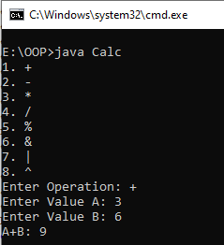

**Conclusion :**

I learnt that how to make a bitwise & arithmetic calculator using java.

**Practical No.: 3** (**b)**

**AIM:** Find largest between three numbers using ternary operator.

**Methodology followed:**

**Input:**

import java.util.*;

class Max

{

public static void main(String args[])

{

Scanner scan = new Scanner(System.in);

System.out.print("Enter Value of A: ");

int a = scan.nextInt();

System.out.print("Enter Value of B: ");

int b = scan.nextInt();

System.out.print("Enter Value of C: ");

int c = scan.nextInt();

int max=(a>b)?((a>c)?a:c):((b>c)?b:c);

System.out.println("Maximum is: "+max);

}

}

**Output:**

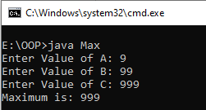

**Conclusion :**

I learnt to find the maximium element with the help of ternary operator.

**Practical No.: 3** (**c)**

**AIM:** Given an array of size N-1 such that it only contains distinct integers in the range of 1 to N. Find the missing element.

**Methodology followed:**

**Input:**

import java.util.*;

class missing1

{

public static int missing(int[] arr)

{

int n=arr.length;

int sum1=((n)*(n+1))/2;

int sum2 = 0;

for(int i=0;i<n;i++)

{

sum2+=arr[i];

}

return sum1-sum2;

}

public static void main(String args[])

{

Scanner sc=new Scanner(System.in);

System.out.print("Enter size of an array : ");

int size=sc.nextInt();

boolean isvalid = true;

int a[]=new int[size];

System.out.print("Enter Elements: ");

for(int i=0;i<size-1;i++)

{

a[i]=sc.nextInt();

if(a[i]<0 || a[i]>size)

{

isvalid=false;

System.out.println("NEGATIVE OR GREATER THAN GIVEN NUMBER FOUND");

break;

}

if(i>0)

{

if(a[i] == a[i-1])

{

isvalid=false;

System.out.println("DUPLICATE Value");

break;

}

for(int j=0;j<i-1;j++)

{

if(a[j]==a[i])

{

isvalid=false;

System.out.println("DUPLICATE Value ");

break;

}

}

if(isvalid==false)

{

break;

}

}

}

if(isvalid)

{

System.out.println("Missing Element: " + missing(a));

}

sc.close();

}

}

**Output:**

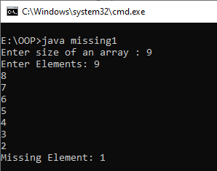

**Conclusion:**

I learnt about how find missing element from 1 to n in O(1) time.

**Practical No.: 3 (d)**

**AIM:** Given an array of positive and negative numbers. Find if there is a subarray with 0 sum.

**Methodology followed:**

**Input:**

import java.util.Scanner;

class pr3d

{

public static void main (String args[])

{

Scanner sc = new Scanner (System.in);

int i, j, sum = 0, n = sc.nextInt ();

int a[] = new int[n], mx = ((n * (n + 1)) / 2);

for (i = 0; i < n; i++)

{

a[i] = sc.nextInt ();

}

int ans = 0;

boolean check = false;

for (i = 0; i < n; i++)

{

ans = a[i];

for (j = i + 1; j < n; j++)

{

ans = ans + a[j];

if (ans == 0)

{

check = true;

break;

}

}

if (check)

break;

}

if (check)

System.out.println ("Yes");

else

System.out.println ("No");

}

}

**Output:**

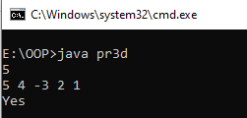

**Conclusion :**

I learnt how to check whether the sum is 0 in any subarray.

**Practical No. : 3(e)**

**AIM:** Given an unsorted array arr[] of size N having both negative and positive

integers. The task is place all negative element at the end of array without changing the order of positive element and negative element.

**Methodology followed:**

**Input:**

import java.util.*;

class pr3e

{

public static void main(String args[])

{

int n,i;

Scanner scan = new Scanner(System.in);

System.out.print("Enter Size of array: ");

n=scan.nextInt();

int a[] = new int[n];

System.out.print("Enter Array Elements: ");

for(i=0;i<n;i++)

{

a[i] = scan.nextInt();

}

System.out.print("Output: ");

for(i=0;i<n;i++)

{

if(a[i]>=0)

{

System.out.print(a[i]+"\t");

}

}

for(i=0;i<n;i++)

{

if(a[i]<0)

{

System.out.print(a[i]+"\t");

}

}

}

}

**Output:**

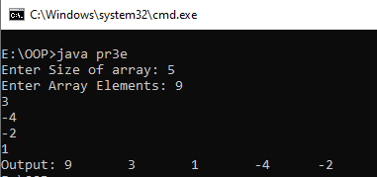

**Conclusion:**

I learnt that how to print positive integer at first and negative integer at last.